**Capabilities covered:**

* Understand the web standards, patterns & protocols
* Define client & server architecture
* Implement Web UI that meets the functional specifications
* Add actions, interactions, business logic using JavaScript (ES6 & TS)
* Develop responsive pages using Material Design, Bootstrap & Media Query
* Develop Rich Web Application using Angular 4+ & Typescript 2.3+
* Use web pack and NPM for building and packaging your application
* Test, and Debug your application to make application ready for deployment
* Follow coding standard and maintain high quality by analyzing various reports generated through code quality tools

## **Instructions**

* Design user interface as per requirement. Use HTML5, CSS3, JavaScript, JSON, Bootstrap, Angular and UI templates
* Web page should follow W3C web standards, should implement SEO, and ARIA
* Externalize CSS and JS code.
* Application should be of Responsive web design
* Use progressive enhancement wherever you can, and don’t sacrifice accessibility for convenience or performance

## **Requirements**

**Mobile Store**

Create a Responsive single page web application to list mobiles available in store. User should be able to filter his/her selection. Filter can be based on Manufacturer, Storage capacity and OS.

When user clicks on any particular mobile, a new pop-up displaying its bigger picture and description should be displayed.

**Note:** No need to implement server-side code. Data required for this application should be available in the form of JSON.

What to implement:

**Requirement 1:**

On page load filter menu and all available mobiles should be loaded as shown below:

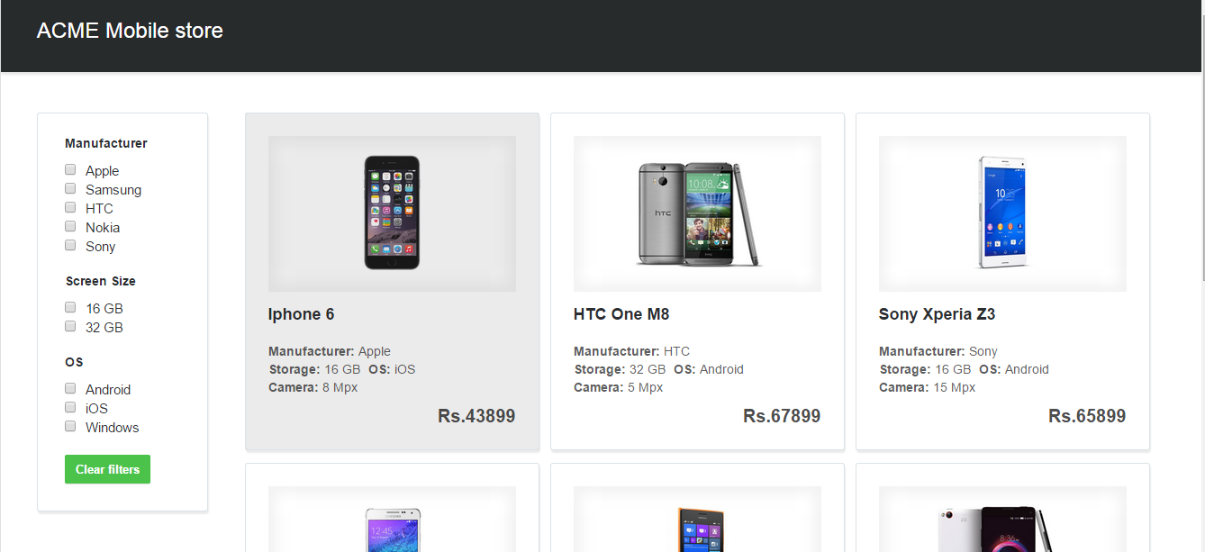

On page resize number of mobiles displayed in a row should change, for example for tablet screens only 2 mobiles in a row, for mobile screens only 1 mobile in a row and for extra large screen 4 mobiles in a row should be displayed.

**Requirement 2:**

When user selects different filter criteria, only mobiles which match the criteria should be opaque and other mobiles should be transparent as shown below:

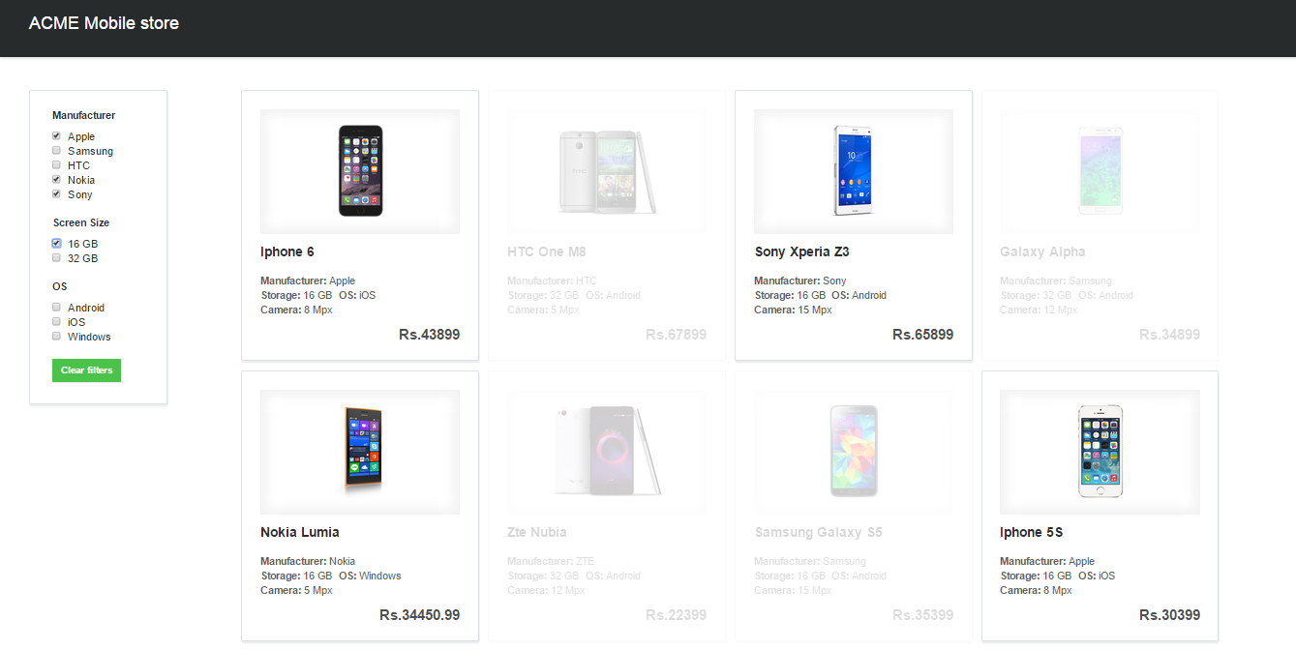

Clicking on “Clear filters” button all the checkboxes should be unchecked and all mobiles should be displayed as mentioned on page load.

**Requirement 3:**

Clicking on any of the displayed mobile its bigger image and description should be displayed.

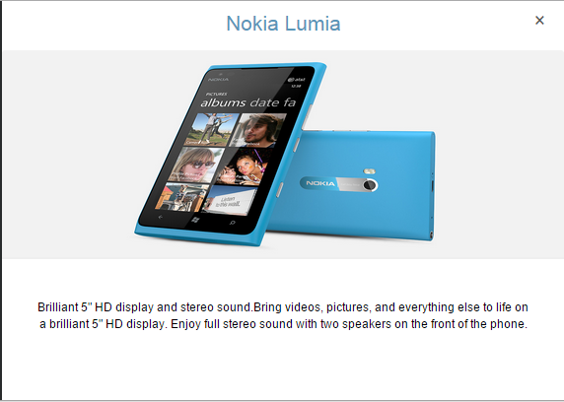

Clicking on “x” close button user is redirected back to previous screen.